Correction TP moteur de recherche

# Ingestion des données

b)

input {

file {

path => "/home/nosql/elasticsearch/data/*"

sincedb_path => "/dev/null"

start_position => "beginning"

}

}

filter{

if "shows" in [path]

{

# on parse le fichier shows

csv {

columns => [ "show_id","title","description","seasons","episodes","follow_count","creation_year","genres","network" ]

skip_empty_rows => true

separator => ","

}

}

else if "episodes" in [path]

{

# on parse le fichier episodes

csv {

columns => [ "episode_id","show_id","show_title","code","season","episode","title","description","released_timestamp" ]

skip_empty_rows => true

separator => ","

}

}

mutate{remove_field => "message"}

}

output {

stdout {

codec => "rubydebug"

}

}

c)

input {  
    file {  
        path => "/home/nosql/elasticsearch/data/*"  
        sincedb_path => "/dev/null"  
        start_position => "beginning"  
    }  
}  
filter{  
     if "shows" in [path]{  
        csv {  
            columns => [ "show_id","title","description","seasons","episodes","follow_count","creation_year","genres","network" ]  
            skip_empty_rows => true  
            separator => ","  
        }  
  } else if "episodes" in [path]{  
        csv {  
            columns => [ "episode_id","show_id","show_title","code","season","episode","title","description","released_timestamp" ]  
            skip_empty_rows => true  
            separator => ","  
        }  
    }  
    mutate { remove_field => "message" }  
  
}  
output {  
   if "episodes" in [path]{  
       # on envoi sur notre ES et sur l'index episodes  
    elasticsearch{  
        hosts => [ "127.0.0.1" ]  
        index => "episodes"  
    }  
  } else if "shows" in [path]{  
      # on envoi sur l'index show  
     elasticsearch{  
        hosts => [ "127.0.0.1" ]  
        index => "shows"  
    }  
  } else {  
    # si il y a une erreur, on l'affiche  
    stdout {  
        codec => "rubydebug"  
    }  
  }  
}

## II Les query Elasticsearch

a)

* shows/_search?q=title:detective&size=50 -> 37 résultats
* shows/_search?q=title:detective AND seasons:[3 TO *] -> 4 résultats
* shows/_search?q=title:batman -description:pingouin -> 9 résultats
* shows/_search?q=description:(alien robot) AND creation_year:[1990 TO 1999] AND genres:"Comedy" -> 5 résultats

b)

Appel en POST à faire sur : ﻿shows/_search

{

"query": {

"match": {

"title": "detective"

}

},

"size":50

}

{

"query": {

"bool": {

"must": [

{

"match": {

"title": "detective"

}

},

{

"range": {

"seasons": {

"gte": 3

}

}

}

]

}

}

}

{

"query": {

"bool": {

"must": [

{

"match": {

"title": "batman"

}

}

],

"must_not": [

{

"match": {

"description": "pingouin"

}

}

]

}

}

}

{

"query":{

"bool":{

"must":[

{

"match":{

"description":"alien robot"

}

},

{

"match":{

"genres":"Comedy"

}

},

{

"range":{

"creation_year":{

"gte":"1990",

"lte":"1999"

}

}

}

]

}

}

}

{

"sort": [

{

"episodes": "desc"

}

],

"query": {

"term": {

"title": "Star Trek"

}

}

}

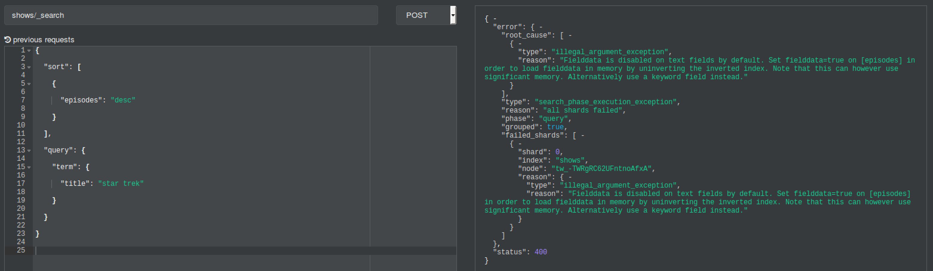

# III - Réindéxation

Mapping Shows

PUT shows-v2

{

"_settings":{

"number_of_shards":4,

"number_of_replicas":1

},

"mappings":{

"doc":{

"properties":{

"show_id":{

"type":"integer"

},

"title":{

"type":"keyword",

"fields":{

"french":{

"type":"text",

"analyzer":"french"

}

}

},

"description":{

"type":"text",

"analyzer":"french",

"fields":{

"english":{

"type":"text",

"analyzer":"english"

}

}

},

"seasons":{

"type":"integer"

},

"episodes":{

"type":"integer"

},

"genres":{

"type":"text",

"analyzer":"french",

"fields":{

"analyzed":{

"type":"text",

"fielddata": true,

"analyzer":"simple"

}

}

},

"network":{

"type":"keyword"

},

"creation_year":{

"type":"date",

"format":"year"

},

"follow_count":{

"type":"integer"

}

}

}

}

}

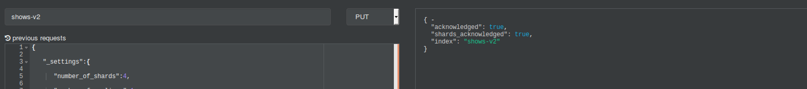

Mapping episodes-v2

PUT episodes-v2

{

"_settings":{

"number_of_shards":4,

"number_of_replicas":1

},

"mappings":{

"doc":{

"properties":{

"show_id":{"type":"integer"},

"show_title":{

"type":"keyword",

"fields":{

"french":{

"type":"text",

"analyzer":"french"

}

}

},

"title":{

"type":"text",

"analyzer":"french",

"fields":{

"english":{

"type":"text",

"analyzer":"english"

}

}

},

"description":{

"type":"text",

"analyzer":"french",

"fields":{

"english":{

"type":"text",

"analyzer":"english"

}

}

},

"season":{"type":"integer"},

"episode":{"type":"integer"},

"released_timestamp":{

"type":"date",

"format":"epoch_second"

},

"code":{

"type":"keyword"

}

}

}

}

}

1. Un champ de type Keyword n’est pas indexé et analysé -> c’est considéré comme une valeur exacte (clé)

c)

Réindexation :

POST _reindex

﻿{

"source": {

"index": "shows"

},

"dest": {

"index": "shows-v2"

}

}

Ne fonctionne pas. Il faut supprimer l’enregistrement qui contient les noms de colonnes.

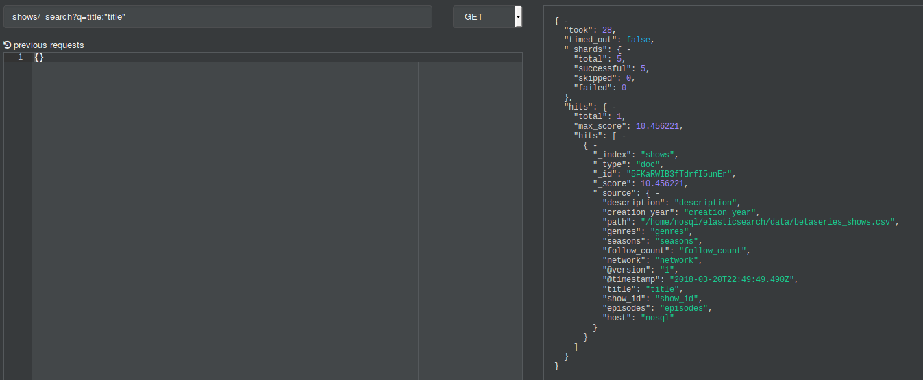

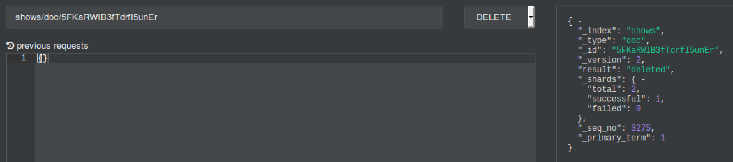

Réindexation des shows :

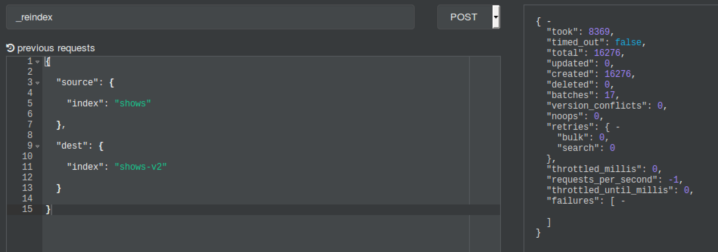

POST _reindex

﻿{

"source": {

"index": "episodes"

},

"dest": {

"index": "episodes-v2"

}

}

Idem, il faut supprimer l’enregistrement suivant :

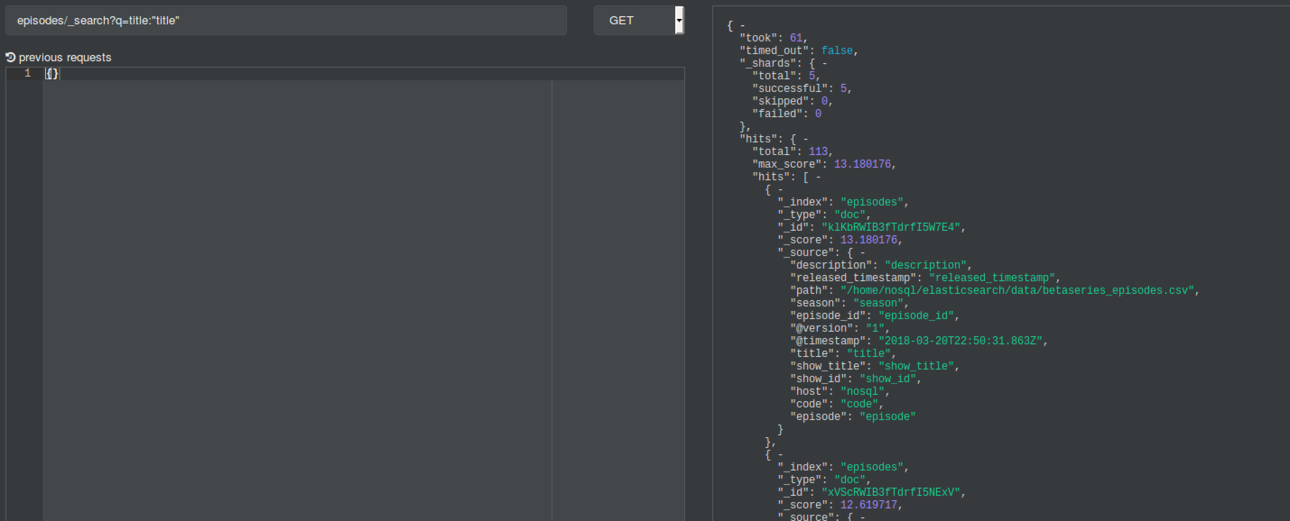

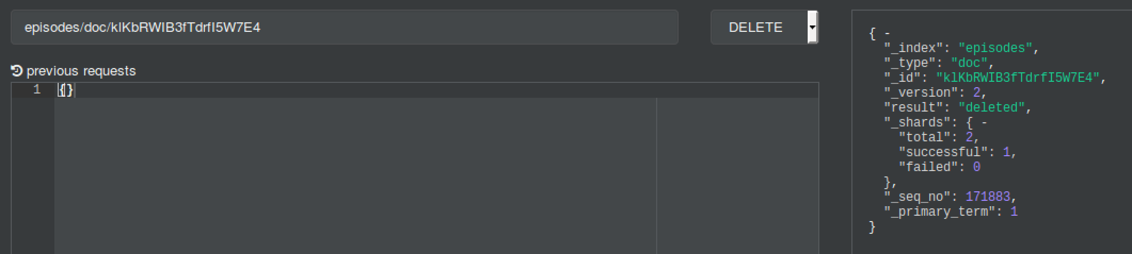

Réindexation des épisodes. ATTTENTION, IL FAUT ATTENDRE.

d) Les 3 premières requêtes ne renvoient pas de résultat car Keyword implique une recherche exacte, or il n’y a pas de document possédant le titre (exact) « detective » ou « batman ».

Par contre, quand on fait une recherche exacte sur le titre « True Detective », la recherche renvoie un résultat.

Appel en POST à faire sur : ﻿shows-v2/_search

{

"query": {

"match": {

"title": "True Detective"

}

},

"size":50

}

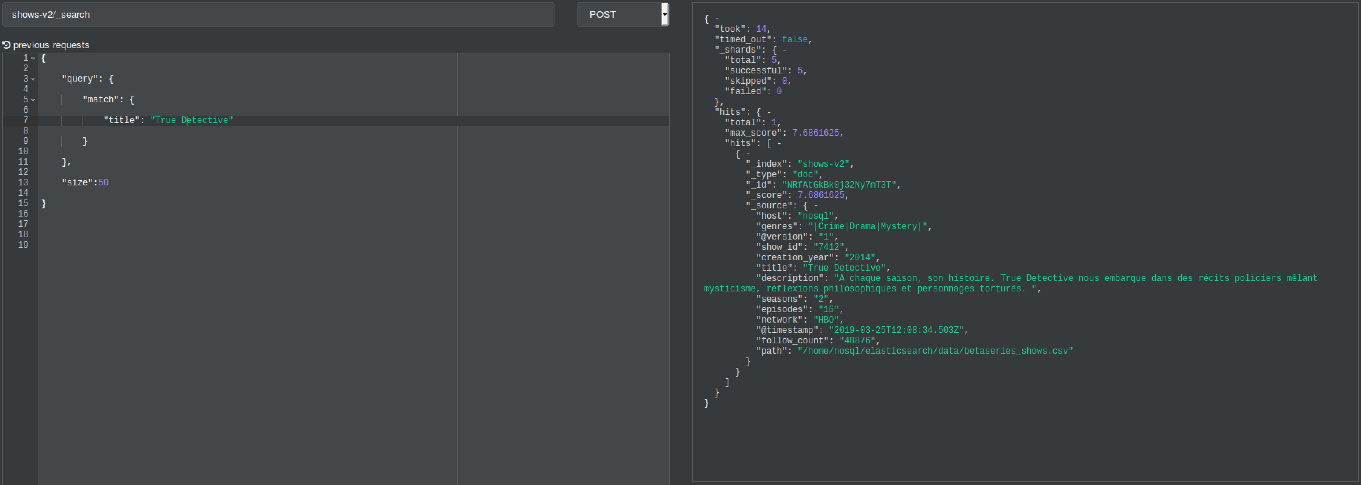

e)

{

"sort": [

{

"episodes": "desc"

}

],

"query": {

"term": {

"title": "Star Trek"

}

}

}



f) GET _analyze

{

"text": "Comment reparer un vélo avec une brosse à dent",

"analyzer": "french"

}

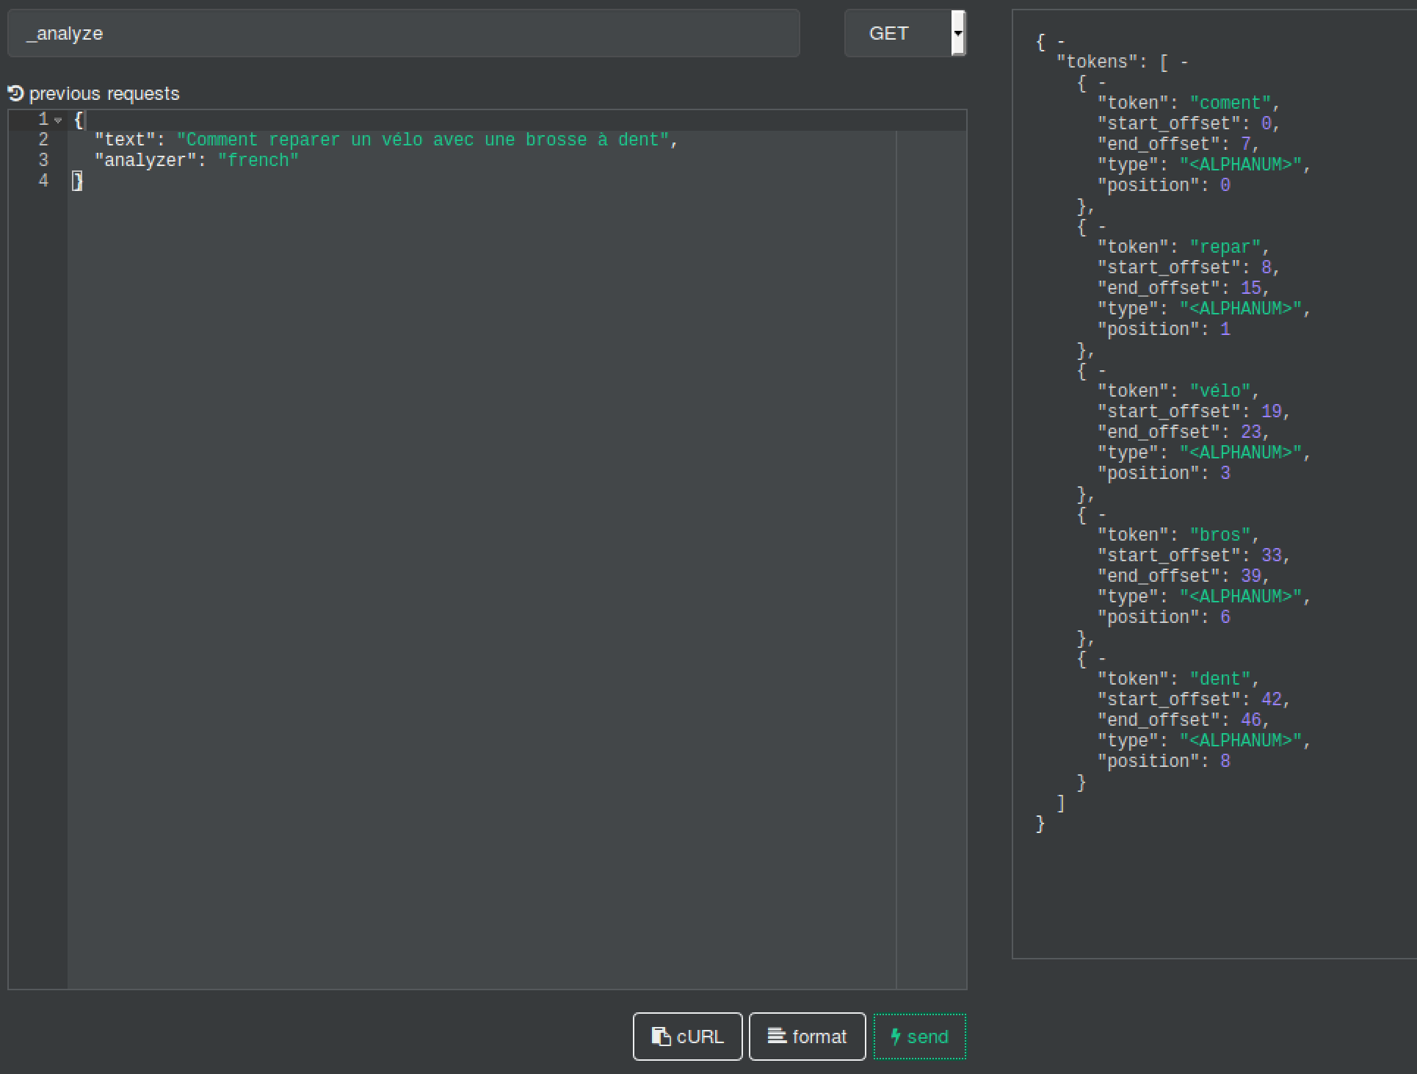

## IV – Aggregations

1:

{

"size":0,

"aggs" : {

"avg_seasons" : { "avg" : { "field" : "seasons" } },

"avg_followers" : { "avg" : { "field" : "follow_count" } }

}

}

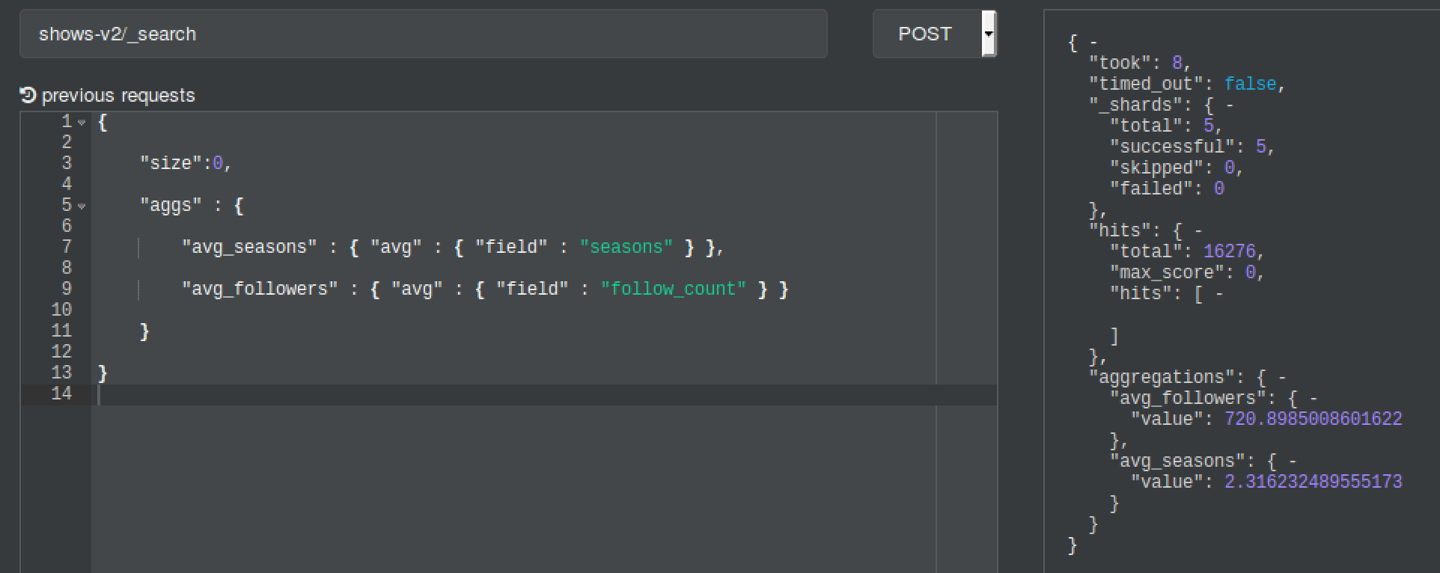

2 :

{

"query": {

"match": {

"title.french": "doctor who"

}

},

"size": 0,

"aggs": {

"avg_followers": {

"avg": {

"field": "follow_count"

}

}

}

}

3 :

{

"query": {

"range": {

"creation_year": {

"gte": "1968"

}

}

},

"size": 0,

"aggs": {

"shows_per_year": {

"date_histogram": {

"field": "creation_year",

"interval": "year"

},

"aggs": {

"avg_followers": {

"avg": {

"field": "follow_count"

}

}

}

}

}

}

4 :

{

"query": {

"range": {

"creation_year": {

"gte": "1900"

}

}

},

"size": 0,

"aggs": {

"networks": {

"terms": {

"field": "network",

"size":3

},

"aggs": {

"shows_per_year": {

"date_histogram": {

"field": "creation_year",

"interval": "year"

}

}

}

}

}

}

5 :

﻿{

"size": 0,

"aggs": {

"nb_seasons": {

"range" : {

"field" : "seasons",

"ranges" : [

{ "to" : 2 },

{ "from" : 2, "to" : 3 },

{ "from" : 4, "to" : 6 },

{ "from" : 7 }

]

}

}

}

}

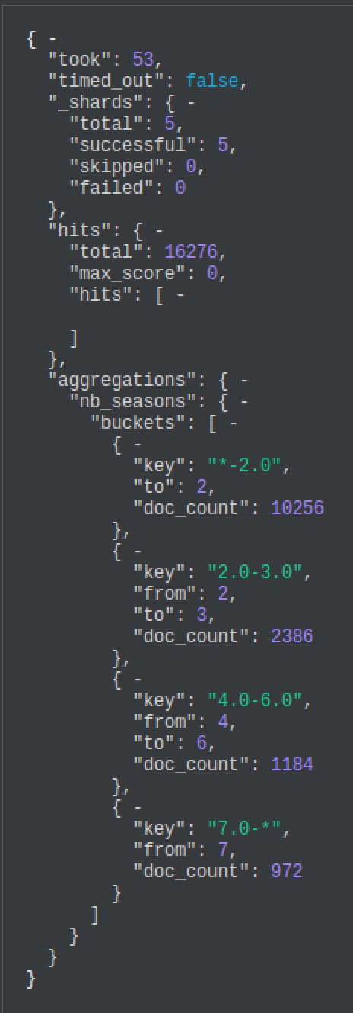

6 :

{

"query": {

"range": {

"creation_year": {

"gte": "2017"

}

}

},

"size": 0,

"aggs": {

"shows_per_year": {

"date_histogram": {

"field": "creation_year",

"interval": "year"

},

"aggs": {

"genres": {

"terms": {

"field": "genres.analyzed",

"size": 5

}

}

}

}

}

}

Il faut accéder au champ analyzed de genres.

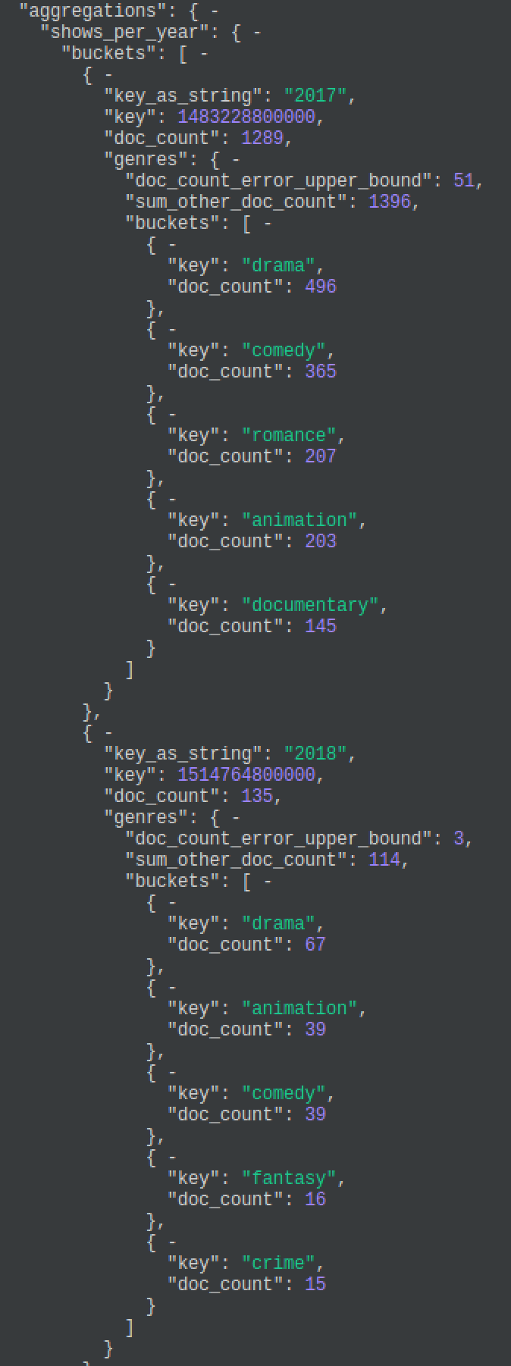

## V – Sharding

1. Les carrés verts plein sont des shards primaires et les carrés en pointillés sont des replicas -> des copies de sauvegarde des shards primaires. En cas de défaillance d’un nœud, il faut que le backup soit accessible ailleurs sur le cluster. C’est la raison pour laquelle shards primaire et replicas ne sont pas sur le même nœud
2. Si c’est le nœud master qui est coupé, l’instance sur le port 9200 ne répondra plus mais les autres instances continueront à répondre sur leurs ports respectifs.